- COMPARISON OF DDR3, DDR4, DDR5 RAM

- INTRODUCTION:

Random Access Memory (RAM) is a temporary memory that stores data and instructions while the computer is running. It allows the CPU to access data quickly, making the system faster and more responsive. RAM is volatile memory, which means its data is erased when the computer is turned off. The three most common generations of RAM are DDR3, DDR4, and DDR5. Each new generation offers higher speed, lower power consumption, better performance, and improved efficiency.

- COMPARISON TABLE

FEATURE | DDR3 | DDR4 | DDR5
Full Form | Double Data Rate 3 | Double Data Rate 4 | Double Data Rate 5
Release Year | 2007 | 2014 | 2020
Speed | 800-2133 MT/s | 2133-3200 MT/s | 4800-8400+ MT/s
Voltage | 1.5V (1.35V for DDR3L) | 1.2V | 1.1v
Bandwidth | Lower | Higher | Highest
Power Consumption | High | Lower than DDR3 | Lowest
Maximum Capacity | Up to 16GB | Up to 64GB | Upto 128GB or more
Performance | Basic | Fast | Very Fast
Typical Use Cases | Older PCs, office Work | Gaming, Programming, Office, Multitasking | AI, Video Editing, 3D Rendering, High-End Gaming
Motherboard Support | DDR3 Motherboard | DDR4 Motherboard | DDR5 Motherboard
Compatibility | Only DDR3 Slots | Only DDR4 Slots | Only DDR5 Slots

- TYPES OF RAM ARE DDR3, DDR4, DDR5

- DDR3 RAM:

DDR3 is an older generation of memory mainly found in older desktop computers and laptops. It provides sufficient performance for basic tasks such as web browsing, Microsoft Office, online classes, and watching videos. However, it consumes more power and offers lower speed compared to newer RAM generations.

- DDR4 RAM:

DDR4 is currently the most widely used RAM in desktop computers and laptops. It provides higher speed, lower power consumption, and better multitasking performance than DDR3. DDR4 is an excellent choice for students, programmers, gamers, and office users because it delivers strong performance at an affordable price.

- DDR5 RAM:

DDR5 is the latest generation of RAM designed for modern computers. It offers significantly higher speed, greater bandwidth, lower power consumption, and supports much larger memory capacities. DDR5 is ideal for high-end gaming, artificial intelligence (AI), professional video editing, 3D rendering, engineering software, and other demanding applications.

- TYPICAL USE CASES:

- DDR3: Basic computing, web browsing, MS Office, online learning.
- DDR4: Gaming, programming, office work, graphic design, video editing, multitasking.
- DDR5: AI development, machine learning, professional content creation, 4K/8K video editing, CAD software, virtualization, high-end gaming.

- KEY DIFFERENCES:

- DDR5 is much faster than DDR4, and DDR4 is faster than DDR3.
- DDR5 consumes the least power, improving energy efficiency.
- DDR5 supports the largest memory capacity.
- DDR3 is mainly used in older systems.
- DDR4 offers the best balance of price and performance.
- DDR5 is designed for future technologies and demanding workloads.

- CONCLUSION:

DDR3, DDR4, and DDR5 are different generations of RAM, each offering improvements in speed, efficiency, and performance. DDR3 is suitable for older computers and basic tasks, DDR4 remains the best choice for most users because of its balance of cost and performance, while DDR5 delivers the highest performance for advanced gaming, professional content creation, AI, and future-ready systems. Selecting the correct RAM depends on your motherboard compatibility, budget, and performance requirements.

- RAM MODULE IDENTIFICATION AND REINSTALLATION

- INTRODUCTION:

Random Access Memory (RAM) is a temporary memory that stores data and instructions required by the CPU while the computer is running. It helps improve system speed and multitasking. In this practical task, the installed RAM module was identified, removed safely, reinstalled correctly, and the system was checked to ensure it booted successfully.

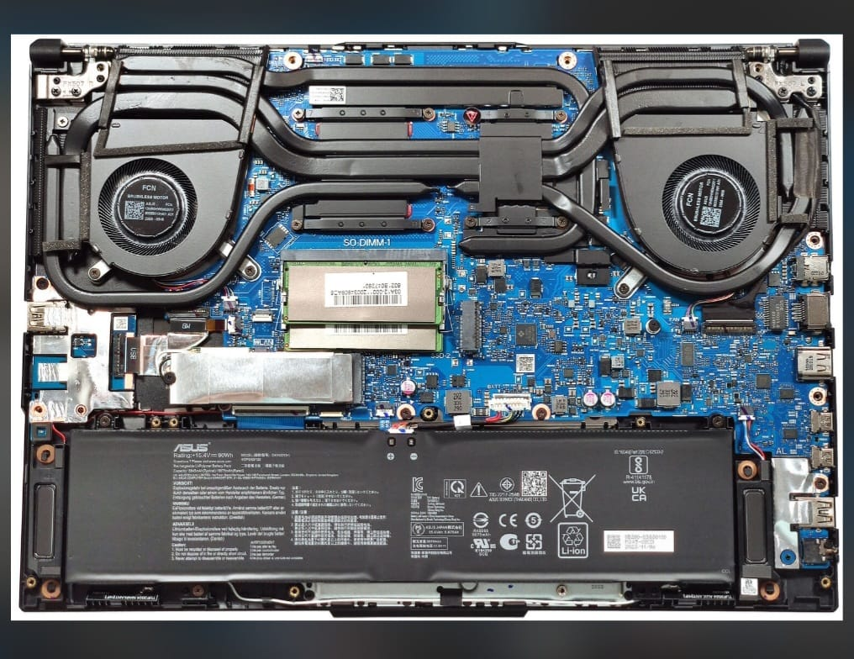

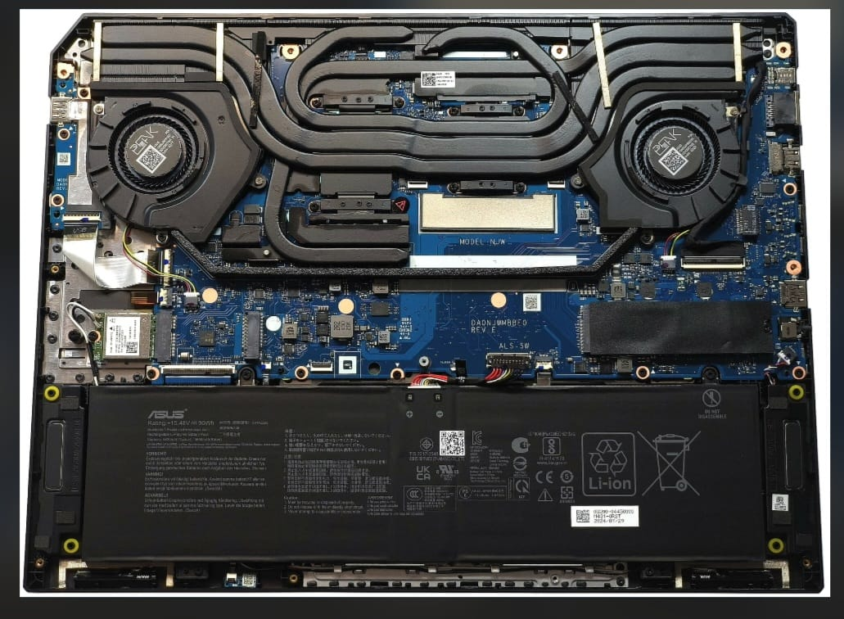

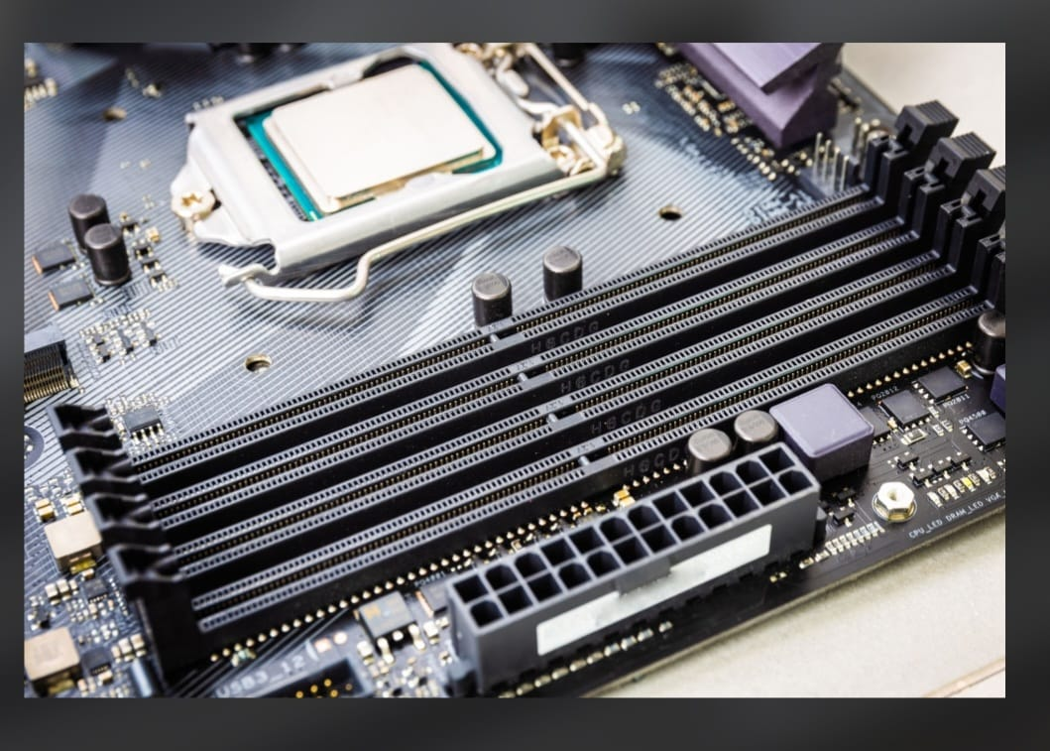
- OBJECTIVE:

- To identify the installed RAM module.
- To safely remove and reinstall the RAM.
- To verify that the computer detects the RAM after reinstallation.

- MATERIALS REQUIRED:

- Laptop/Desktop Computer
- Screwdriver
- Anti-static precautions.

- PROCEDURE:

- Shut down the computer completely.
- Disconnect the power cable and charger.
- Remove the battery (if removable).
- Open the back panel of the laptop or desktop cabinet.
- Locate the installed RAM module.
- Take a clear photo of RAM module before removing it.
- Press the side clips gently to release the RAM.
- Carefully remove the RAM module.
- Reinsert the RAM into the same slot at the correct angle.
10.Press gently until both locking clips click into place.
11. Close the cabinet/back panel.
12. Reconnect the power and turn on the computer.
13. Verify that the system boots successfully and detects the installed RAM.

- OBSERVATION:

- RAM Module Identified: DDR4 / DDR5 (write the actual type).
- Installed Capacity: 8 GB / 16 GB (write your actual RAM).
- RAM was removed and reinstalled successfully.
- The computer started normally.
- Windows detected the installed RAM correctly without any errors.

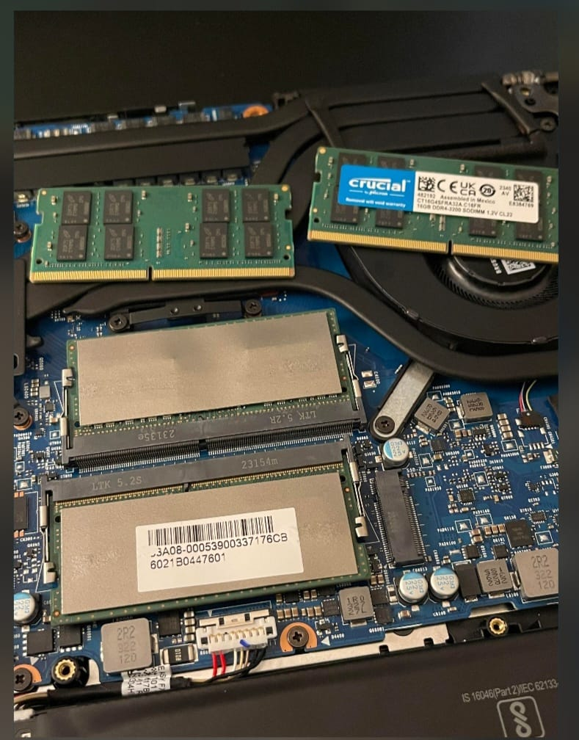

- RESULT:
The RAM module was successfully removed and reinstalled. The system booted normally, and Windows recognized the installed memory correctly.

- CONCLUSION:

This practical helped me understand the location, installation process, and importance of RAM in a computer. I learned how to safely remove and reinstall a RAM module while ensuring that the system recognizes it after reassembly.

- HDD vs SSD vs NVMe STORAGE COMPARISON

- INTRODUCTION:

Storage devices are used to permanently store the operating system, applications, and personal files. The three most common storage types are HDD (Hard Disk Drive), SSD (Solid State Drive), and NVMe SSD. Each offers different levels of speed, performance, and reliability depending on the user's needs.

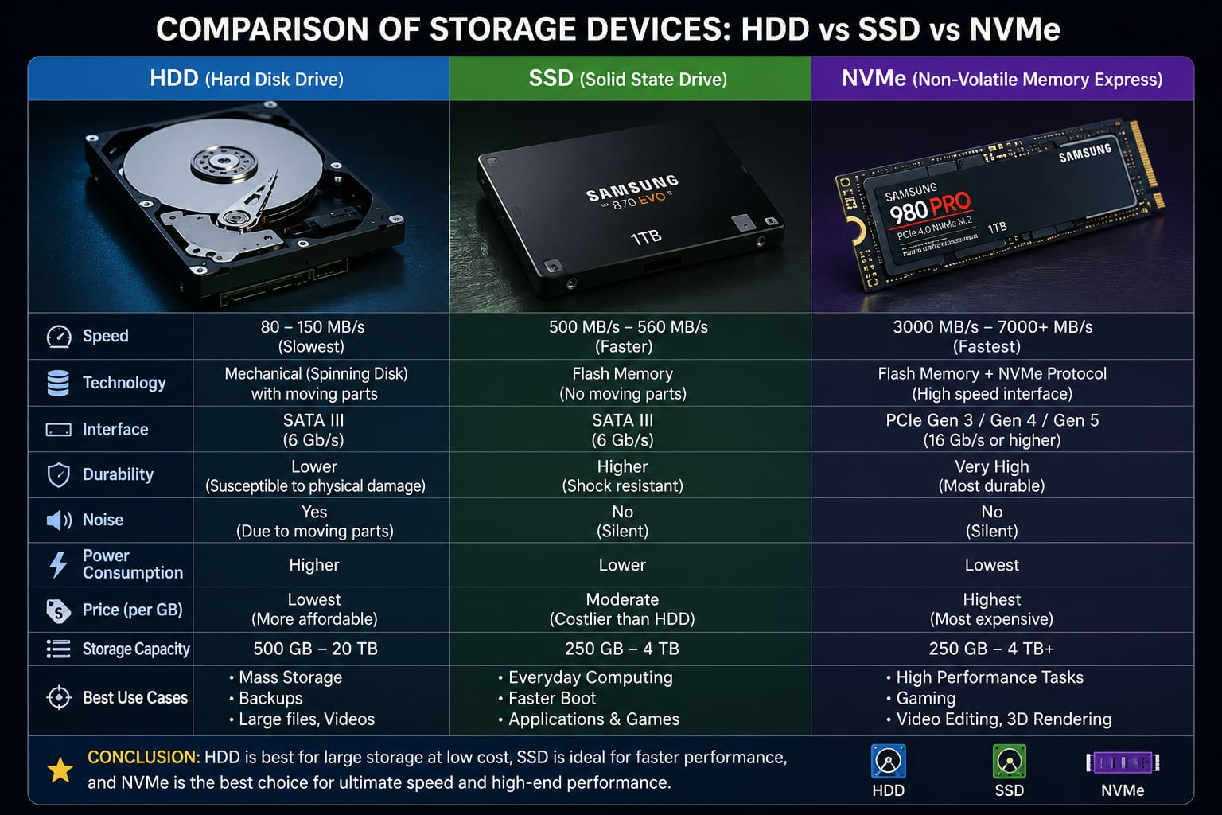

- COMPARISON TABLE

FEATURE | HDD | SSD (SATA) | NVMe SSD
Technology | Mechanical spinning disk | Flash memory | Flash memory using PCle interface
Read/Write Speed | 80-160 MB/s | 450-550 MB/s | 2,000-7000+ MB/s
Boot Time | Slow | Fast | Fastest
Noise | Makes noise | Silent | Silent
Durability | Lower | High | Very High
Cost | Cheapest | Medium | Most Expensive
Best Use | Large file storage | Daily computing | Gaming & Professional Work

- THREE KEY DIFFERENCES:

- SPEED:

HDD: Slowest because it uses spinning disks.
SSD: Much faster than HDD.
NVMe: Fastest storage technology available for consumer PCs.

- PERFORMANCE:

HDD: Suitable for basic storage and backups.
SSD: Provides faster boot time, quick application loading, and smooth multitasking.
NVMe: Best for high-performance tasks such as gaming, video editing, AI, and software development.

- PRICE:

HDD: Lowest cost with high storage capacity.
SSD: Moderate price with good performance.
NVMe: Highest price but delivers the best speed and efficiency.

- BEST APPLICATION / USE CASE:

- HDD: Storing movies, photos, documents, backups, and CCTV recordings.
- SSD: Windows OS, Microsoft Office, Google Chrome, Visual Studio Code, and everyday applications.
- NVMe SSD: AAA Games (GTA V, Cyberpunk 2077), Adobe Premiere Pro, Blender, AutoCAD, Android Studio, and virtual machines.

- CONCLUSION:

HDD, SSD, and NVMe all serve different purposes. HDD is ideal for affordable large-capacity storage, SSD offers excellent speed for everyday computing, and NVMe provides the highest performance for gaming and professional workloads. The right storage device should be selected based on budget, storage requirements, and performance needs.

- STORAGE DRIVE IDENTIFICATION AND REINSTALLATION

- INTRODUCTION:

A storage drive is an important component of a computer that stores the operating system, software applications, and personal files. Common storage devices include Hard Disk Drive (HDD) and Solid State Drive (SSD). SSDs may use SATA or M.2/NVMe connectors. In this practical task, the storage drive was identified, removed, reinstalled, and checked to ensure the system recognized it correctly.

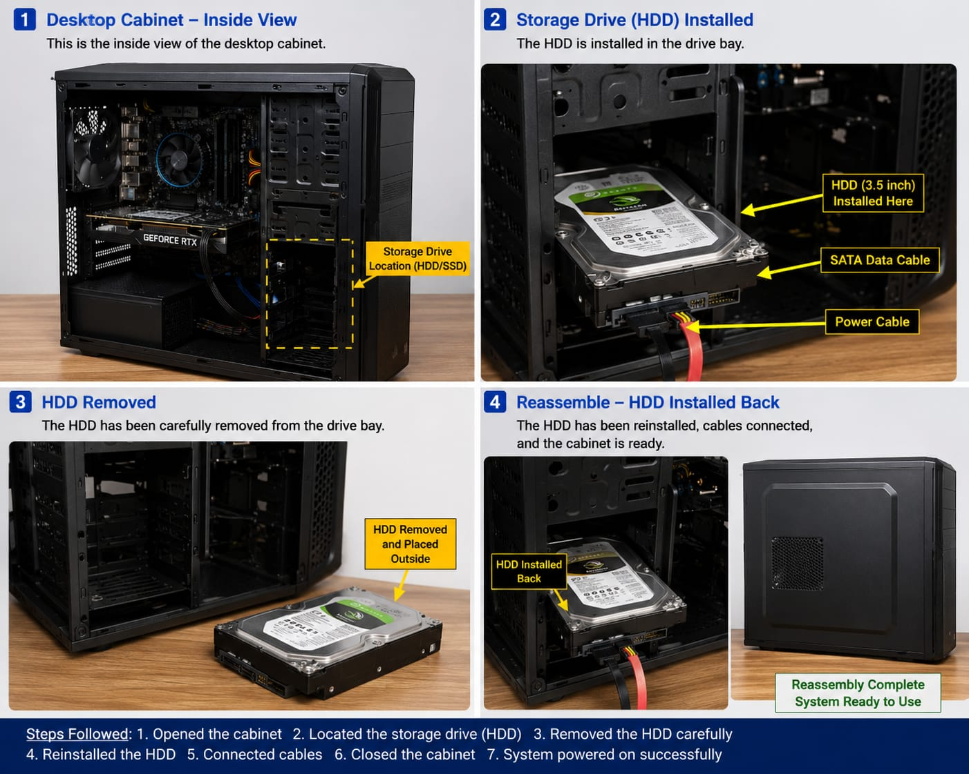

- OBJECTIVE:

- To identify the installed storage drive.
- To identify the connector type (SATA, M.2, NVMe).
- To safely remove and reinstall the storage device.
- To verify that the operating system detects the storage after reassembly.

- MATERIALS REQUIRED:

- Laptop/Desktop computer
- Screwdriver
- Anti-static precautions

- PROCEDURE:

- Shut down the computer completely.
- Disconnect the charger and power supply.
- Open the back panel or computer cabinet carefully.
- Locate the installed storage drive.
- Identify the connector type (SATA, M.2, or NVMe).
- Take a clear photo of the storage drive and its connector.
- Remove the storage drive carefully.
- Reinstall it securely in the same slot.
- Close the back panel and reconnect the power.
10.Turn on the computer.
11.Confirm that the storage drive is detected correctly in Windows.

- OBSERVATION:

- Storage Device: SSD / HDD (write the actual one).
- Connector Type: SATA / M.2 / NVMe (write the actual type).
- The storage drive was removed and reinstalled successfully.
- The system started normally.
- Windows recognized the storage device without any errors.

- RESULT:
The storage drive was successfully removed and reinstalled. After reassembly, the computer booted normally, and Windows detected the storage device correctly.

- CONCLUSION:

This practical helped me understand the different storage connector types and the correct procedure for removing and reinstalling a storage device. It also improved my knowledge of basic computer hardware maintenance and troubleshooting.

